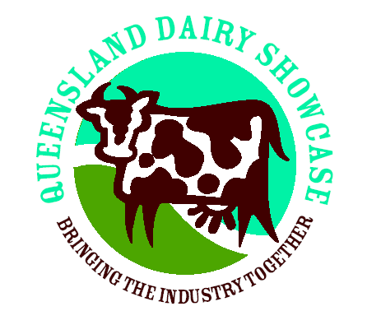
Queensland Dairy Showcase

Sponsorship Packages

Platinum Sponsor Package $1000 and over

- Acknowledgement at announcement of class(s) for judging, during judging and at conclusion of judging
- Acknowledgement against the relevant class(s) in the schedule with your logo
- General acknowledgement in schedule
- Presentation of ribbons and prizes by your nominated representative to the respective winner(s).
- Advertising material to be distributed to the audience.
- Photo opportunity with winner(s).
- Signage around the judging ring(s).
- General acknowledgment throughout the day.
- Recognition in Schedule with page advertisement if you provide copy.
- Acknowledgment during class(s).
- Logo throughout schedule.
- Trade stand space available if required in Dairy Precinct
- Invitation to and speaking opportunity at Exhibitors Social Function on Judging Night
- Show pass for two (2) people.

Gold Sponsor Package $500 - $1000

- Acknowledgement at announcement of class(s) for judging, during judging and at conclusion of judging
- Acknowledgement against the relevant class(s) in the schedule with your logo
- General acknowledgement in schedule
- Presentation of ribbons and prizes by your nominated representative to the respective winner(s).
- Advertising material to be distributed to the audience.
- Photo opportunity with winner(s).
- Signage around the judging ring(s).
- General acknowledgment through out the day.
- Recognition in Schedule with advertisement if you provide copy.
- Acknowledgment during class(s).
- Invitation to Exhibitors Social Function on Judging Night (Thursday)
- Show pass for two (2) people.

Silver Sponsor Package $100 - $500

- Acknowledgement at announcement of class(s) for judging, during judging and at conclusion of judging
- Acknowledgement against the relevant class(s) in the schedule with your logo
- General acknowledgement in schedule
- Presentation of ribbons and prizes by your nominated representative to the respective winner(s).
- Advertising material to be distributed to the audience.
- Photo opportunity with winner(s).
- Signage around the judging ring.
- General acknowledgment through out the day.
- Invitation to Exhibitors Social Function on Judging Night (Thursday)
- Show pass for one (1) person.

Bronze Sponsor Package $100 – Under

- Acknowledgement at announcement of class for judging, during judging and at conclusion of judging
- Acknowledgement against the relevant class in the schedule with your logo
- General acknowledgement in schedule
- Invitation to Exhibitors Social Function on Judging Night (Thursday)
- Presentation of ribbons and prizes by your nominated representative to the respective winner.

In addition to these benefits at Qld Dairy Showcase you will also receive the benefits of being a Gatton Show Sponsor commensurate with the level of sponsorship. A copy of these will be provided on request.

